First I create a repository to store the basic programming code:

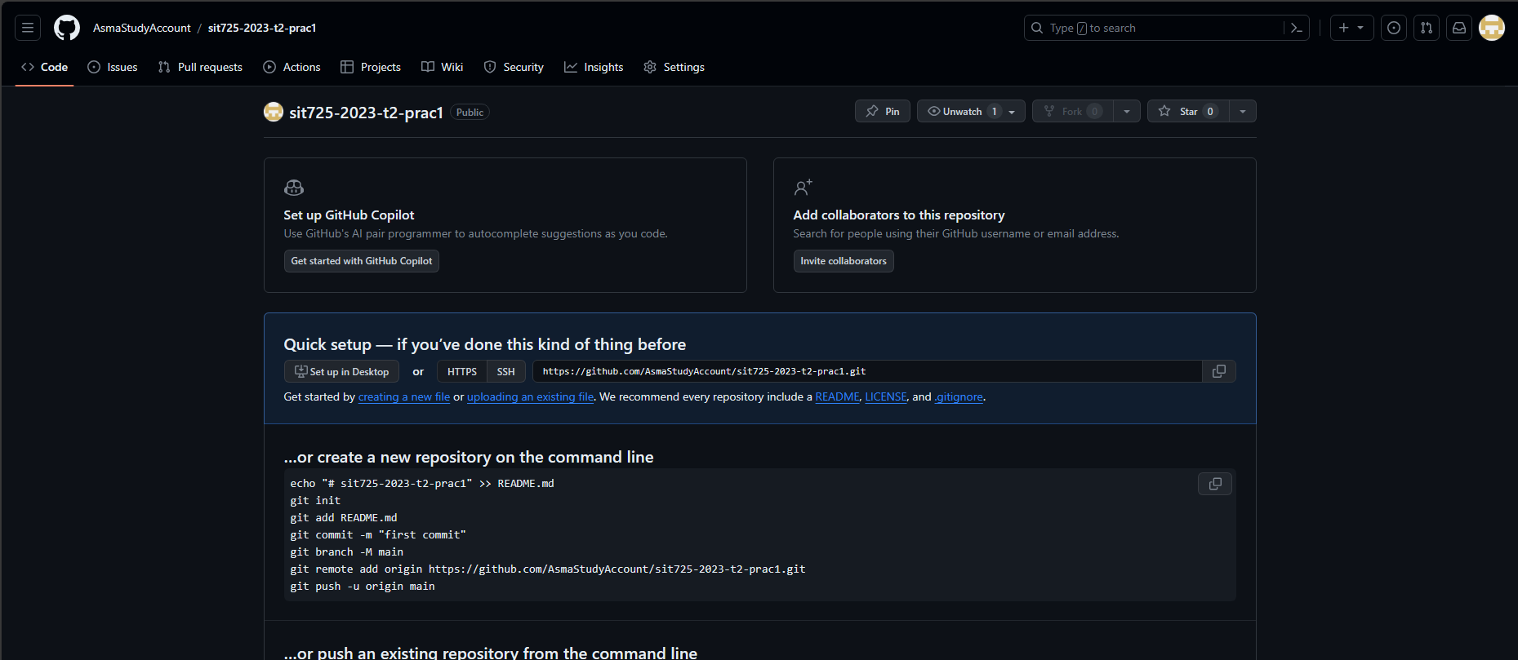

This is the link to that repository:

<https://github.com/AsmaStudyAccount/sit725-2023-t2-prac1>

Then I clone it with Git :



It is an empty repository so it will look like this: 

Then create some file to make my first basic programming code: 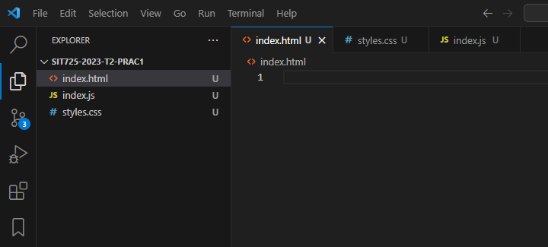

Then add some code for it

For the html code I have this structure:

<!DOCTYPE html>

<html lang="en">

  <head>

    <meta charset="UTF-8" />

    <meta name="viewport" content="width=device-width, initial-scale=1.0" />

    <title>Simple Counter</title>

    <link rel="stylesheet" href="styles.css" />

  </head>

  <body>

    <div class="container">

      <h1>Simple Counter</h1>

      <div id="displayNumber">0</div>

      <button id="incrementButton">Increment</button>

    </div>

    <script src="index.js"></script>

  </body>

</html>

Where there is a title said counter and a number display 0 (the beginning)

Then a button so that you can increase this number

In css there is some simple styles:

body {

  font-family: Arial, sans-serif;

  text-align: center;

  background-color: #f4f4f4;

}

.container {

  margin-top: 100px;

}

#displayNumber {

  font-size: 2em;

  margin: 20px;

}

button {

  padding: 10px 20px;

  font-size: 1em;

  color: white;

  background-color: #007bff;

  border: none;

  border-radius: 5px;

  cursor: pointer;

}

button:hover {

  background-color: #0056b3;

}

Then in the javascript file I add a simple logic to increase the number by 1 when click the increment button:

document.addEventListener("DOMContentLoaded", function () {

  var count = 0;

  var displayNumber = document.getElementById("displayNumber");

  var incrementButton = document.getElementById("incrementButton");

  incrementButton.addEventListener("click", function () {

    count++;

    displayNumber.textContent = count;

  });

});

The basic programming code now can turn to the website to test it

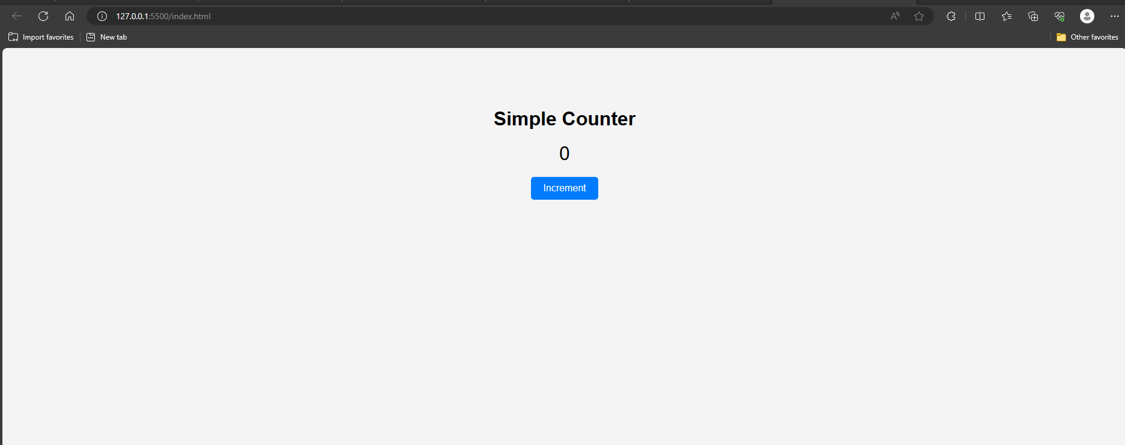

After click the button

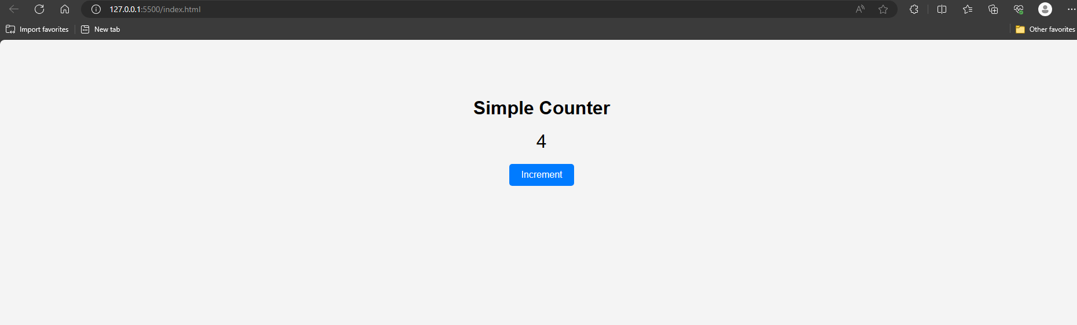

After that check the status from git:

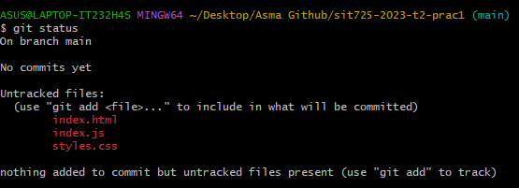

It said that there is new files that is untracked.